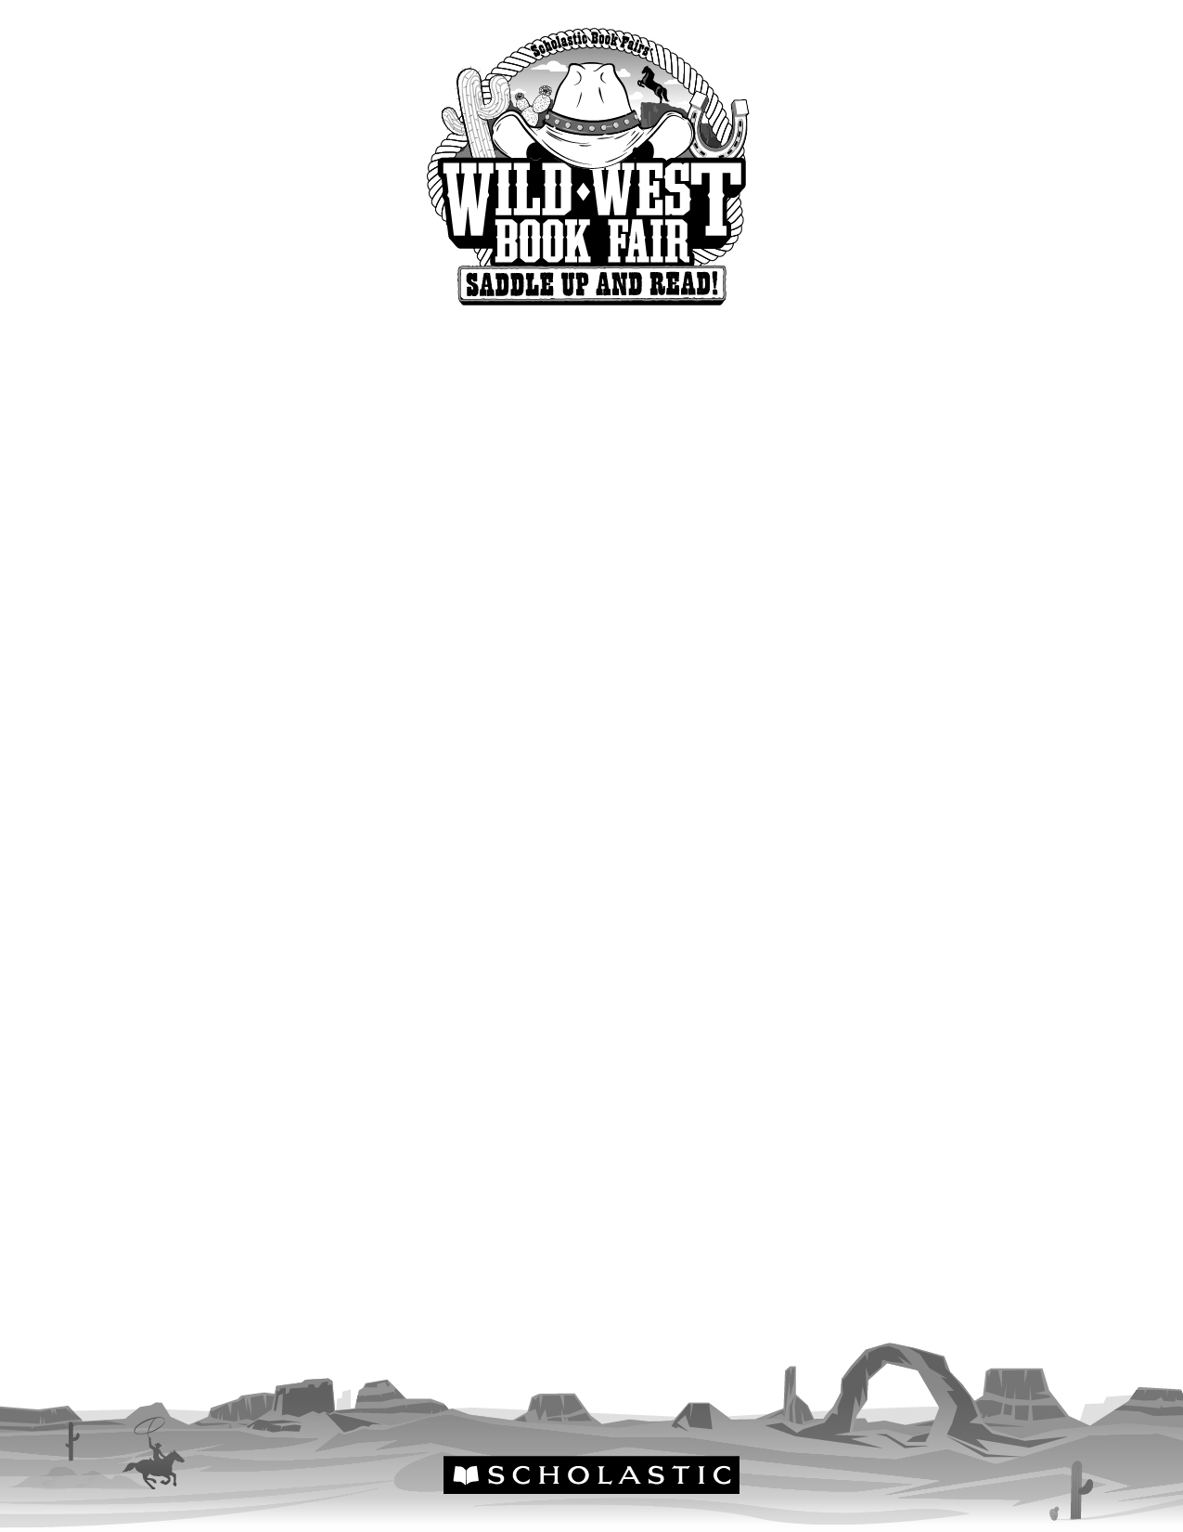

Dear Parents and Families,

The Scholastic Book Fair will be at our school [Insert Date Here] and special Family Events are scheduled for [Insert Date Here].

Our Book Fair theme for fall 2017 is Wild West Book Fair: Saddle Up and Read! Readers are wanted and adventure awaits in books galore at this season’s Book Fair!

We need your help! Please complete the form below by circling the areas that you are interested in volunteering. Thank you so much! Return the form to [Insert Contact Info Here].

Sincerely,

[Insert Name Here]
Book Fair Chairperson

Sign me up to help at the Book Fair!

Name Telephone
Email

I have circled areas where I’d like to help:
• Advertising • Decorating
• Setting up the Fair • Securing community sponsors
• Serving refreshments • Helping shoppers at the Fair
• Checkout • Packing up the Fair
• [Insert Additional Info Here] • Preparing food/baked goods
Permission to reproduce this item is
granted by Scholastic Book Fairs®.
© 2017 Scholastic Inc. All rights reserved. 14045 F17 • 200006

